Detector-Plane Imaging (DPI): Camera-Back Physics and Imprint-Field Dynamics
Author: Srikar R.
Date: December 2025

Abstract
DPI provides a measurement-plane method for imaging nonlinear field coherence directly on the detector surface. Using φ⁴ field dynamics, we demonstrate coherent ring formation, oscillon breathing, accumulated-intensity buildup, and coherence-dependent double‑slit interference. These effects map naturally onto established optical measurements. DPI reframes the detector plane as an active coherence-imaging boundary.

1. Introduction
DPI interprets detector‑plane intensity patterns as imprint fields encoding coherence evolution.

2. Field Model and Equations
Key governing equations:
• φ⁴ dynamics: ∂²φ/∂t² = ∇²φ + m²φ − λφ³
• Detector intensity: I(x,y,t) = φ²
• Far‑field transform: F(k) = |FFT{I(x,y)}|²
• Coherence length: ξ defined via 1/e decay of spectral peak
• Oscillon width: σ = sqrt(<r²>)
Conceptual Narrative
Detector-Plane Imaging (DPI): Conceptual Narrative
1. Camera-Back Physics: The Starting Point
DPI begins by treating the detector not as a passive endpoint but as a dynamic measurement surface. By analyzing raw detector-plane intensity evolution over time, we identified three observable regimes: coherence, decoherence, and decoherence decay. These regimes are visible directly in the spatial structure of the detector-plane data.
2. Oscillon Analogy: A Classical Nonlinear Parallel
To understand these detector-plane structures, we turned to nonlinear field theory. The φ⁴ oscillon exhibits ring formation, breathing, and gradual decoherence patterns that closely match detector-plane outputs in DPI. This provided a useful classical analog that mirrors the geometry of coherence evolution.
3. Photon Parallel: Shared Observables Through Coherence
We then extended the comparison to photons. Although not equivalent objects, photons and oscillons share the same observable coherence signatures on detectors. Single-photon interference experiments confirm the same patterns DPI reveals in oscillon simulations: fringe buildup, visibility decay, and coherence-dependent structures.
4. Existing Instruments Already Perform DPI
Modern experimental systems—ICCDs, EMCCDs, sCMOS sensors, and SPAD arrays—already capture the same patterns that DPI predicts. Ring structures, speckle emergence, and coherence-dependent far-field bands appear in real labs using standard optical setups. DPI provides the missing interpretive framework for these measurements.
5. The Complete DPI Simulation Pipeline
With these parallels established, DPI integrates oscillon dynamics, photon-style detection statistics, double-slit propagation, accumulated-intensity buildup, and Fourier-domain diagnostics. This produces a full simulation pipeline matching laboratory behavior and detector-plane observables.
6. From DPI to Quantum Microscopy
The logical endpoint of this framework is Quantum Microscopy—imaging coherence directly at the detector plane. This reframes the detector as an active coherence sensor and unifies wave-like and particle-like measurement interpretations as two aspects of the same detector-plane phenomenon.

3. Results

Figure 1. Imprint Field Evolution
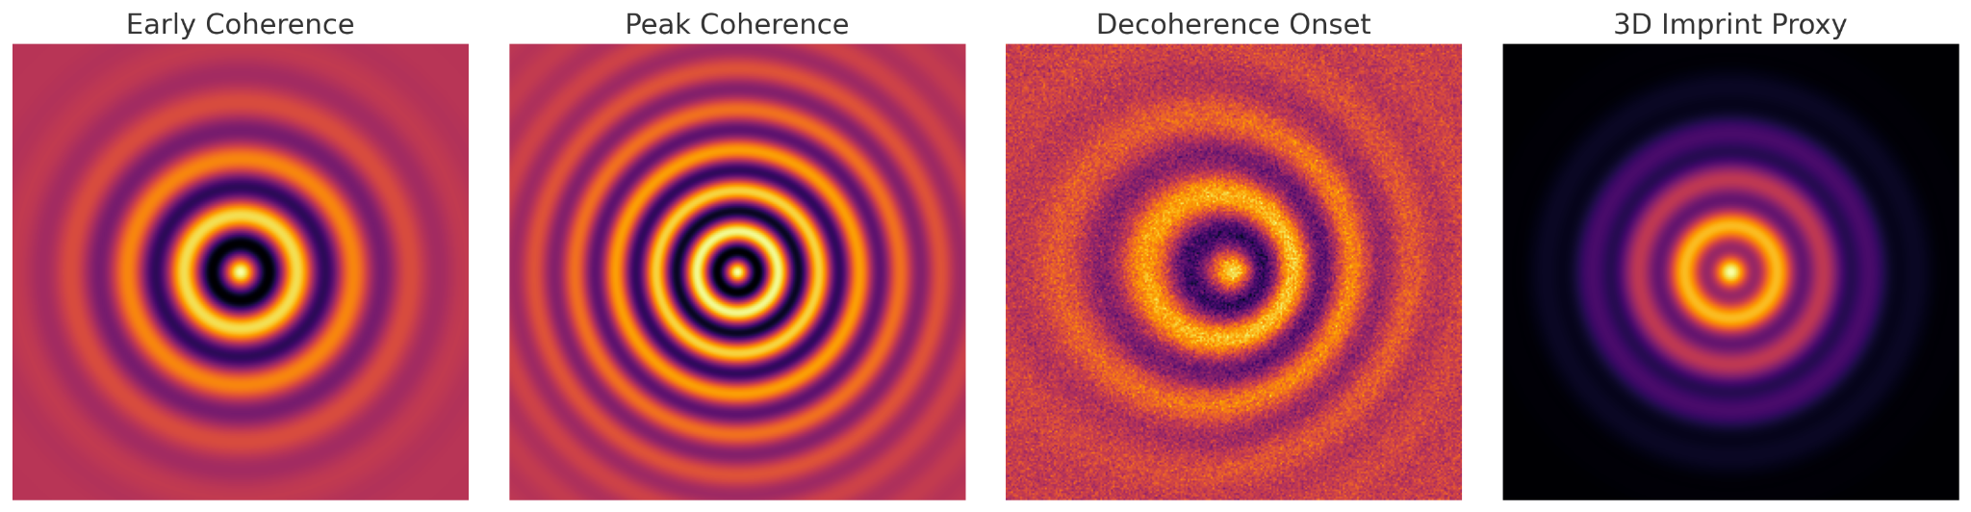
Figure 1. Coherent-ring emergence, peak‑contrast phase, and decoherence onset.

Figure 2. Accumulated Intensity Buildup
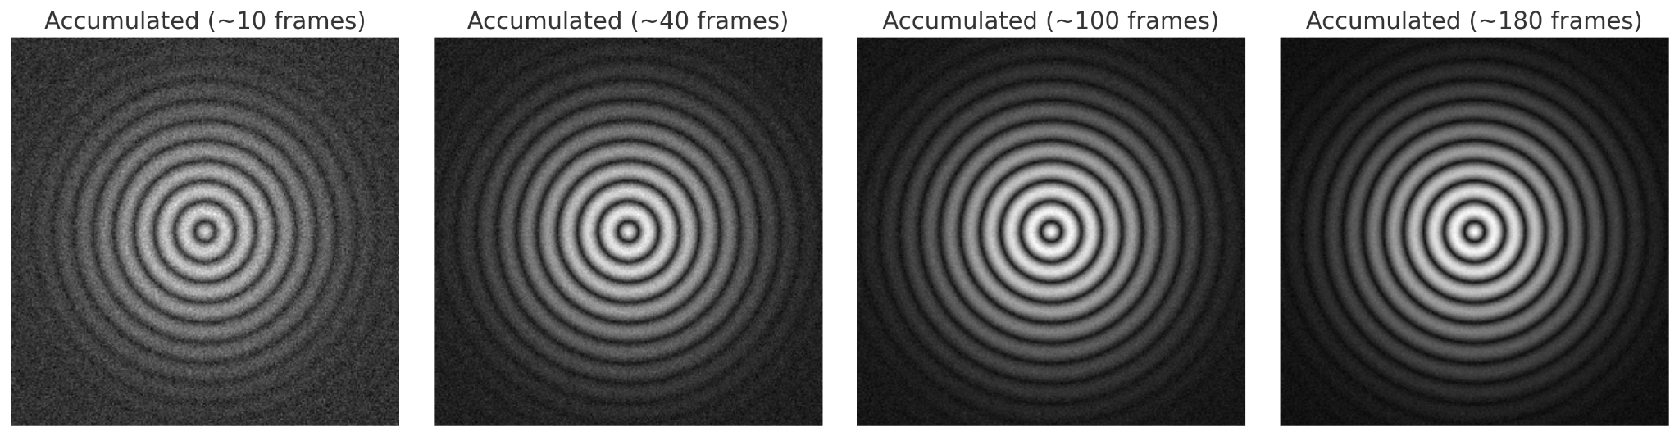
Figure 2. Progressive accumulation revealing stable imprint‑field structure.

Figure 3. DPI Double‑Slit Illumination
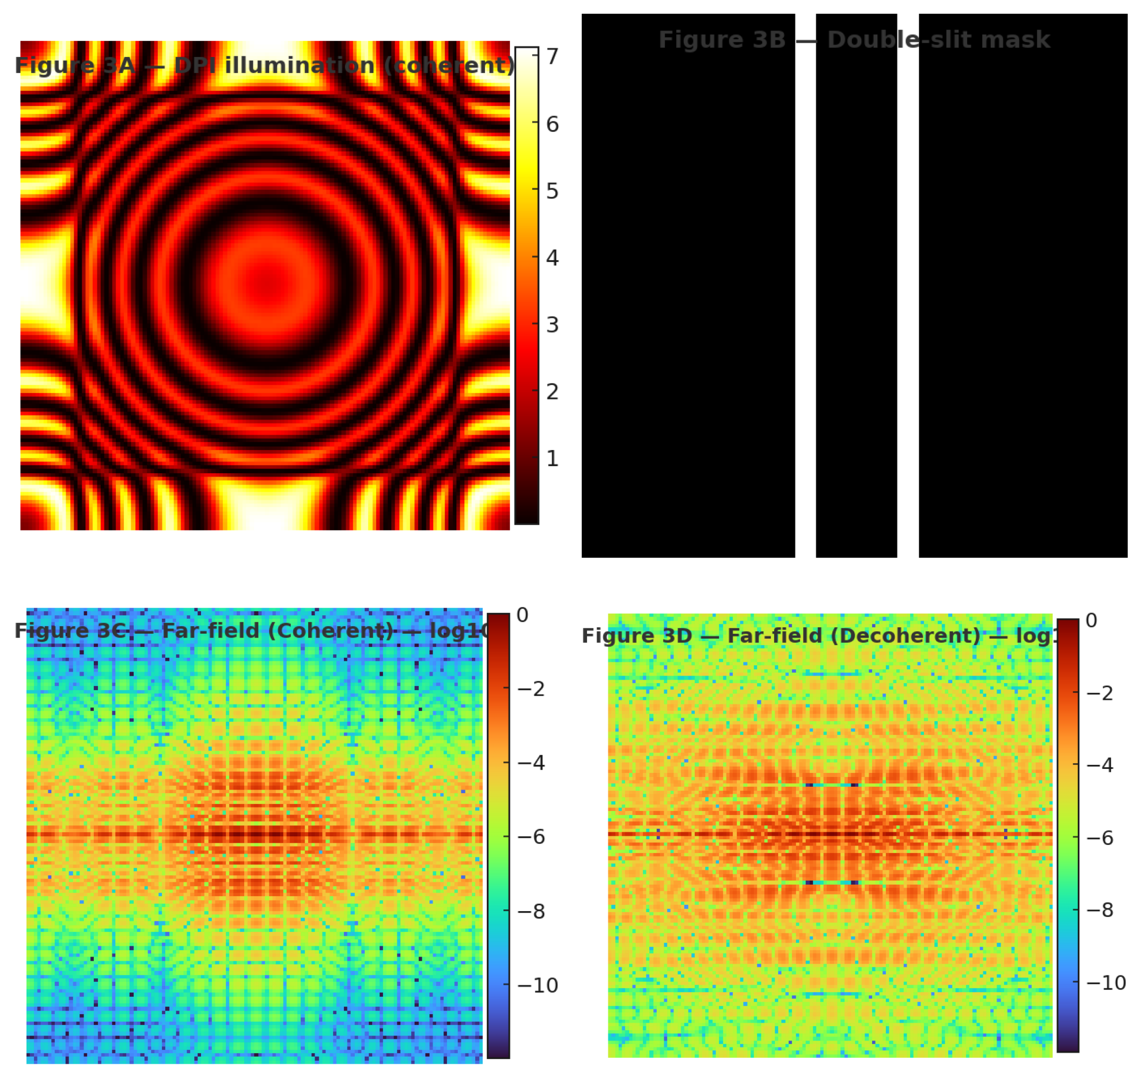
Figure 3. Coherent and decoherent far‑field patterns derived from DPI illumination.

Figure 4. Quantitative Diagnostics
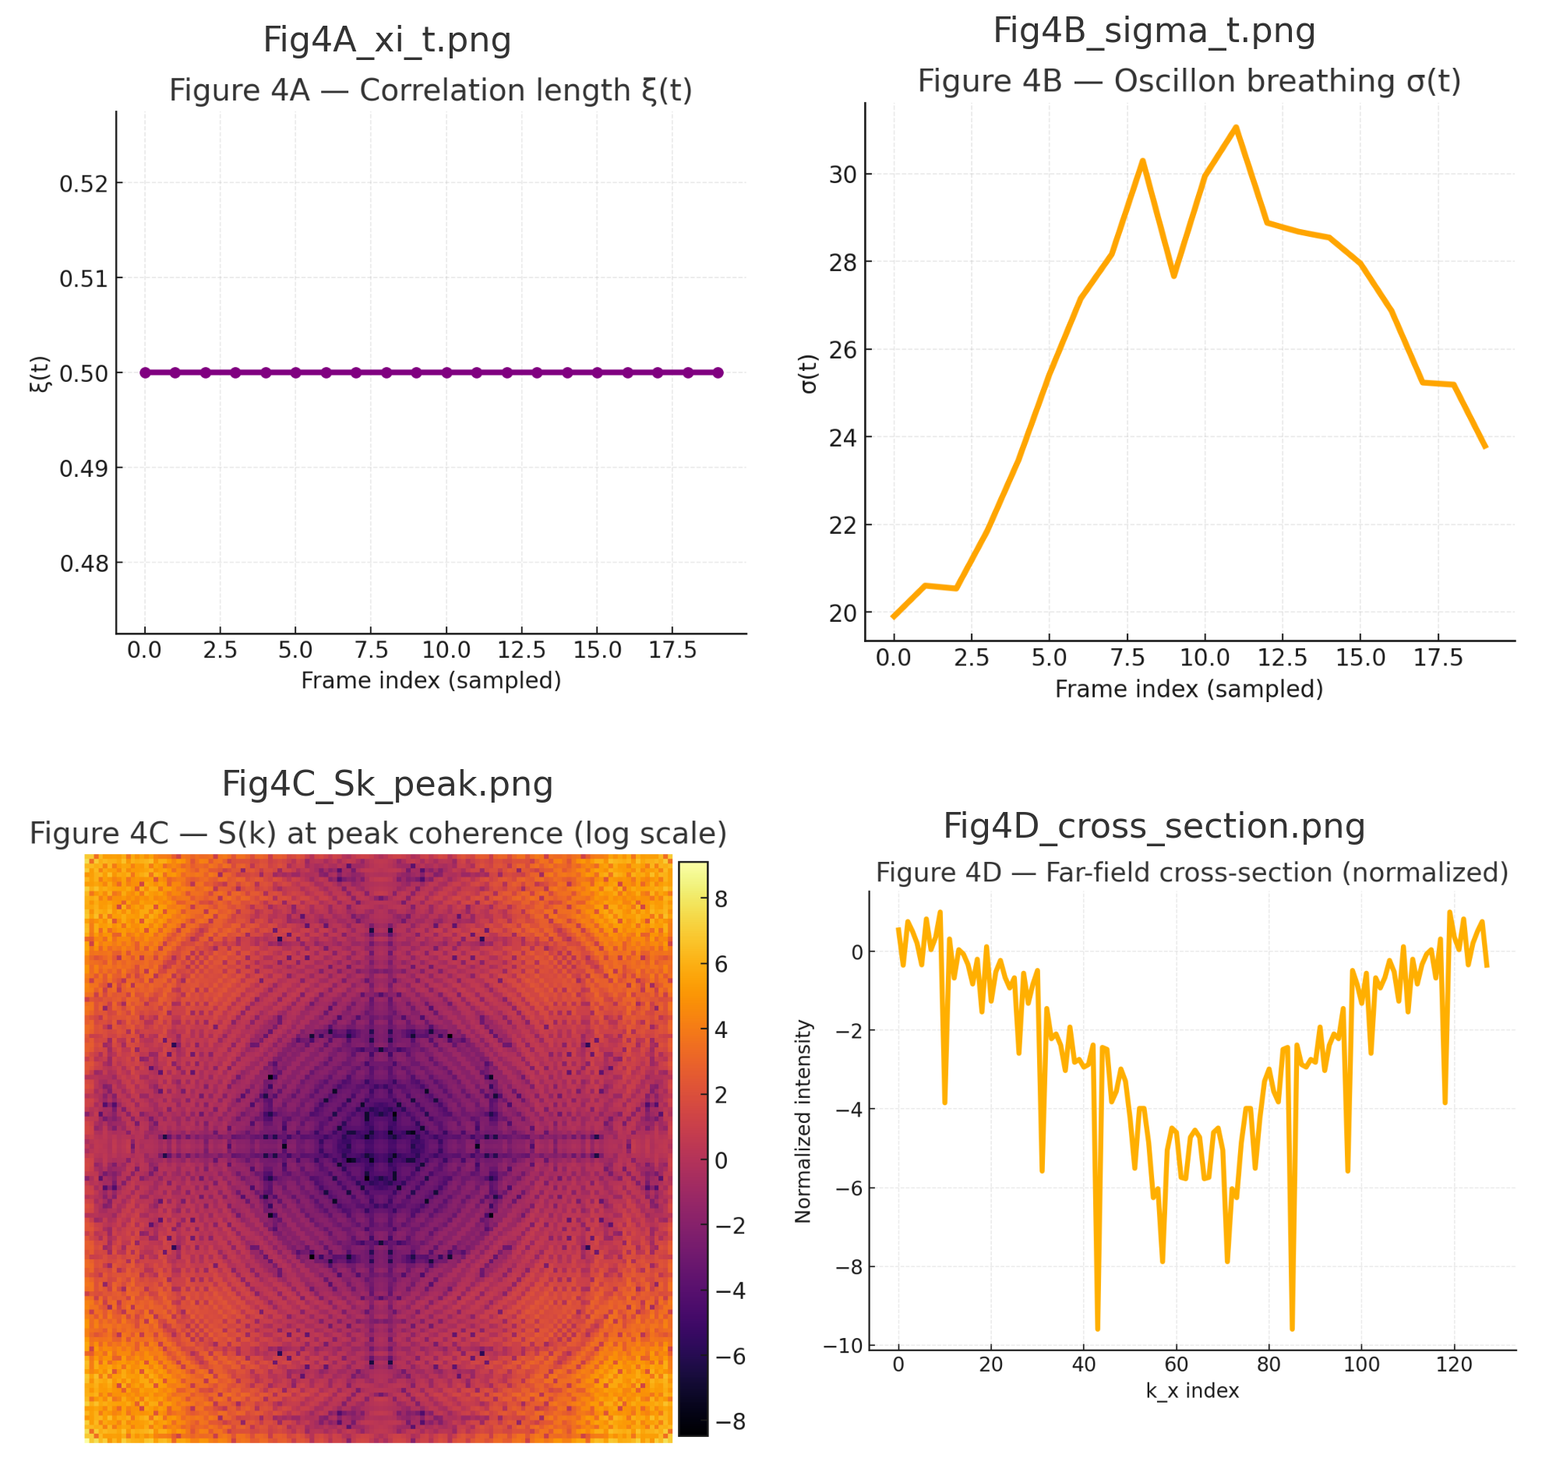
Figure 4. ξ(t), σ(t), Fourier‑space coherence S(k), and far‑field cross‑sections.
Photon–Oscillon Parallel: Practical and Conceptual Bridge
Detector-Plane Imaging emphasizes a pragmatic correspondence between the imprint-field structures we simulate (oscillons and their breathing, rings, and coherence envelopes) and the measurable outputs recorded by contemporary optical instrumentation. This is not a metaphysical identification of photons with classical oscillons. Rather, it is a useful operational mapping: both oscillons (in nonlinear φ⁴ dynamics) and photon fields (in quantum and classical optics) generate structured intensity patterns on a detector plane whose spatial statistics, coherence length, and far-field transforms are directly comparable. Framed this way, DPI offers an experimental protocol: reproduce the imprint-field geometry on a bench-top optical platform (parametric down-conversion, high-gain OPO, or structured laser illumination) and record the detector-plane intensity without intervening imaging optics. The observed patterns—rings, breathing, and coherence-dependent far-field bands—are the shared, testable observables that connect the two descriptions.

Practical Instrumentation and Immediate Tests
Practical Instrumentation and Immediate Tests
The DPI protocol is compatible with equipment already common in optical laboratories. To facilitate rapid adoption, we list practical instrument classes and a minimal test procedure:
• Intensified sCMOS or ICCD cameras (e.g., Andor iStar, PI-MAX, Hamamatsu) for gated, single-shot imaging at nanosecond scales.
• EMCCD cameras (e.g., Andor iXon series, Princeton ProEM) for low-light, accumulated-frame studies that reproduce single-photon buildup.
• SPAD arrays (SwissSPAD2, MegaFrame, Lincoln Lab arrays) for time-tagged single-photon mapping and high temporal resolution diagnostics.
• High-speed CMOS sensors (including Raspberry Pi HQ and modern smartphone sensors) for bright-source demonstrations and rapid prototyping.
Minimal DPI test procedure:
1. Place the selected camera at the detector plane (z = z0) without imaging optics between source and sensor.
2. Illuminate with a spatially structured coherent source (high-gain PDC, OPO, or a structured laser beam that mimics the oscillon profile).
3. Record short-exposure frames and an accumulation series; inspect for concentric rings, breathing behavior, and evolving speckle structure.
4. Insert a simple double-slit mask at the detector plane and verify the far-field double-band pattern under coherent illumination and its fading under decoherence.
Because these procedures use standard hardware and simple masks, DPI experiments can be deployed immediately in most optics labs. We recommend saving raw frames and providing the unprocessed intensity arrays alongside any published figures to maximize reproducibility.

